**1. INTRODUCTION**

**1.1 About Project:**

E-Agri is a web-based project which is useful for farmers and agricultural students. This is an open discussion portal providing solutions to small farmers and agricultural students. It also provides soil analysis for all regions and suggestions on which fertilizers to use where and how much? And which crop, herb or vegetable to be grown where and in which season? It also helps to make decisions on market and best prices. Information about major crop markets and their current price for the crop will be published daily. NGO’s are trying to spread messages to make agriculture more eco-friendly through this site. This also includes training scheduled by agricultural officers. Training is requested by students, general public. Training provides information about crops, fertilizers, and market details that are requested. Online query handlings for all users. Information pages should be dynamic so that agricultural admins and administrator can change it.

It is an open discussion portal used for agricultural students and farmers. The general public can use this system for knowing the information about various crops, and the usage of fertilizers to those crops and in which soil these crops give more yield and the climatic conditions for those crops. To achieve a growth rate of 5 percent and above in agriculture by increasing crop production and productivity through effective technology transfer and adoption by farmers. To reduce cost of production through biological methods, increase farmers agricultural income and empower farmers to use land and water resources sustainably. To review the performance of extension department staff to ensure that their performance is fruitful for the farmers and the cost of services is acceptable. To prepare the necessary plans and instructions to face the challenges faced in the development of the agriculture sector and to formulate the specified procedure and directions for the agriculture department.

Agriculture is the practice of cultivating natural resources to sustain human life and provide economic gain. It combines the creativity, imagination, and skill involved in planting crops and raising animals with modern production methods and new technologies. A key to why agriculture is important to business and society is its output — from producing raw materials to contributing to the global supply chain and economic development.

**1.2 Problems faced frequently:**

• Lack of awareness among farmers

• Do not know about market prices about agricultural products

• Do not know about weather condition

• Do not know about how to cultivate crops

**1.3 Solutions to solve problems:**

• Schemes about agriculture

• Discounts of agricultural products

• Different crop details

• Seasonal crop details

• YouTube channels for crops

• Weather report

• Daily prices of vegetables and Agri products

Our ambition is to make agriculture profitable and able to withstand international competition and to improve the living standards of the farmers of Andhra Pradesh. Strengthening the rural economy by providing high demand services to farmers and helping them shift from subsistence agriculture to commercial agriculture without harming the balance of nature. To create profitable and sustainable agriculture that can withstand international competition by promoting diversified crops, adding value to products, and providing necessary market facilities. To achieve a growth rate of 5 percent and above in agriculture by increasing crop production and productivity through effective technology transfer and adoption by farmers. To reduce cost of production through biological methods, increase farmers agricultural income and empower farmers to use land and water resources sustainably. To review the performance of extension department staff to ensure that their performance is fruitful for the farmers and the cost of services is acceptable.

**2. PROJECT ANALYSIS**

**2.1 Purpose of the Project:**

It is an open discussion portal used for agricultural students and farmers. Any public can use this system for knowing the information about various crops, and the usage of fertilizers to those.

**2.2 Existing System:**

Complexity in managing the data related to the agriculture products, soils, fertilizers, mandi/market details.

**2.2.1 Problems in existing system:**

· Lack of security.

· This system does not provide category wise classifications of products.

· Inefficiency in querying details.

· Periodic Report generation takes lot of time.

**2.3 Proposed system:**

The development of this new system contains the following activities, which try to automate the entire process keeping in the view of database integration approach.

* Reduce complexity in managing the data related to the agriculture products, soils, fertilizers, mandi/market details.
* Current system provides different access levels for security.
* Rich user interface is provided in order to interact with application.
* Reports are generated dynamically on a periodic basis.
* Efficiency in querying details.
* User Queries and Answers are maintained.

**2.4 Data collection:**

**Early Spring:**

Beets, Broccoli, Brussels Sprouts, Cabbage, Cauliflower, Carrots, Cress, Lettuce, Onions, Peas, Potatoes, Radishes , Salad Greens, Spinach

**Summer:**

Beans, Butter Beans (Limas), Cantaloupe/Muskmelon, Corn, Cowpeas/Crowder, Cucumbers, Eggplant ,Garlic, Herbs, Okra, Peppers, Pumpkin, Soybeans ,Squash , Sweet Potatoes, Tomatoes, Watermelon

**Fall:**

Beets, Broccoli, Brussels Sprouts, Cabbage, Carrots, Cauliflower, Cress, Lettuce, Peas, Radish, Salad Greens, Spinach, Turnips

**Permanent Crops:**

Asparagus, Blackberries, Blueberries, Grapes, Potato, Onions, Rhubarb, Strawberries, Raspberries. Crops such as tomatoes and peppers will drop their blooms and it can even mess up a peppers ability to produce properly. If the leaves of beans get frost-bitten it can stun them and actually slow down their ability to grown properly.

Frost will kill summer plants. If you do get caught with a late freeze you can cover your plants with newspaper, straw, or plastic. Tomatoes can be covered with 5 gallon buckets or grocery bags but even these will not always protect the tender young plants from the cold. Every gardener learns this hard lesson sooner or later. If frost gets on your plants, you must get up before the sun and sprinkle water on your plants to wash off the frost. If the sun hits the frost, it is too late. The frost is a lethal poison to your plants and they will die.

Mulching summer plants, especially ones that produce all summer or are long growing such as cucumbers, squash, okra, tomatoes, potatoes, peppers, cantaloupe, watermelon or pumpkins. Good mulching reduces a lot of labor by helping to conserve moisture and reducing those hateful, nasty weeds. It also makes the garden pretty and, in the fall, provides humus to be worked into the soil.

**Soil Analysis:**

An accurate soil analysis is vital to understanding your soil. We use high quality laboratory analyses that work specifically for our system.

Before sending soil samples to us please check out Taking a Good Soil Sample and Sending Soil Samples to K.A.S.

From the basis of a detailed soil analysis, and plant tissue analysis when necessary, and - importantly - the additional information that you provide by completing the free soil test worksheet, we build a specific fertilizer recommendation for each soil sample, tailoring the recommendations to your particular operation and goals.

The recommendations will utilize the proven principles of the Kinsey/ Albrecht system of soil fertility management. The aim is to correct and raise the overall soil fertility to improve and maintain yields and/or crop quality. If we have previously made recommendations for the same soil location, and it has been properly identified as such, then these previous analyses and recommendations are taken into account also.

Samples originating outside of the U.S. and Canada require specific USDA clearance, and may also have to be priced differently according to the service you require - please contact us for the proper procedures, and information concerning cost of analysis and turn-around time before sending any soil.

**Fertilizer Recommendations:**

Our recommendation report for each sample has two parts: the soil analysis and recommendation for achieving the proper fertiltiy level.The basic soil analysis will normally include:

Total Exchange Capacity (T.E.C.),Soil pH ,Organic Matter (Humus) as percent ,Nitrogen (N released from colloidal humus),Sulfate (Expressed as elemental sulfur) in ppm, Phosphates (as P205),Olsen value (Included at no charge if pH is above 7.5),Percent Base Saturation of: Calcium, Magnesium, Potassium, Sodium, Other Bases Exchangeable Hydrogen Calcium, Magnesium, Potassium, and Sodium levels - in lbs/acre*

Trace elements: Boron in ppm, Iron in ppm, Manganese in ppm, Copper in ppm, Zinc in ppm

Our recommendations for a specific plan of fertilizer amendments are tailored to your expressed short- or long-term goals and take into account the previous history of crops and fertilizers at the location, farming conditions in the area, your type of operation, fertilizer preferences, and other factors, as supplied by the grower, in addition to the condition of the soil.

We do not sell fertilizers or soil amendments. It is suggested that to the extent possible you work locally to obtain materials from your preferred fertilizer dealership.Since each soil is tested in more detail than is customarily done in various areas, and provided as well with its own specific set of recommendations, some needed materials may not always be stocked by local dealers. This tends to be especially true for those striving to be certified organic growers.

**Taking a Good Soil Sample:**

The way the soil samples are taken is extremely important, as the recommendations you receive from soil tests will only be as good as the samples you send for analysis.

Following the instructions below will assure that the samples you send are taken in the way we need them for a proper analysis.

When to take a soil sample. Soil samples may be collected at any time of the year, provided that the area is not suffering from prolonged drought, that no nitrogen has been applied in the last 30 days and no sulfur has been used in the last six months.Late spring and early summer sampling avoids the rush, shows the soil's fertility at its best and gives time to plan a soil fertility program which can begin directly following harvest if necessary.

However, if no samples have been taken within the last two years, the best time to sample is as soon as circumstances permit.Generally, sampling should be done every year if fertility is high and / or trace elements are being used to achieve top yield from year to year and is useful at the time of fertilization

Collecting the Sample(s):

The sample bag: Use a new soil-sample container, plastic bag or plastic container.

Soil-sample bags are available free from Kinsey Agricultural Services. Zip-loc bags are fine as long as they have never been used - but put Scotch tape over the writing or attach masking tape to write on because all types of marking ink can rub off the bag during shipment. Do not use paper sacks from the grocery store, bread wrappers, or such items, due to possible contamination. Avoid using a plastic bucket that has been used for other purposes. Even repeated washings of a bucket used to mix salt and minerals for feed can still result in contamination of the sample.

Label the sample bags with your name, the farm name if any, field number and sample area.

Prepare a map or sketch of the area for your own records. Make sure the labeling on the bag matches the number of the field and area on your map. Labeling the bags to match the areas before taking the sample helps.

A SOIL PROBE is recommended for easiest and best sampling results. Using a soil probe or shovel, sample down to a depth of 6½ -7 inches (17cm), or to the depth the soil will be thoroughly mixed when worked if that will be deeper than 6½ -7 inches.For no-till crops,orchards, vineyards, pastures, hay meadows, lawns, etc., where soils will not be worked, the depth should be 4 inches (10cm). Sampling to the proper depth is extremely important ifwe are to provide each grower with the correct recommendations. Put the soil, using several probes from like areas to make up the sample, into the sample bag. Soil probes also help check for compaction and allow for root zone analysis. Furthermore, probing your soil is a great way to discover common pests such as grubs and nematodes. Soil probes are invaluable tools for maintaining healthy lawns and gardens.

Removal of obvious debris (roots, leaves, etc.) is fine but unnecessary as it will not adversely affect the sample. If you do remove debris from the sample, be careful that none of the actual soil is removed with it.

Probe the soil every 50 to 100 paces, always taking a minimum of 5 probes per composite sample for smaller areas, and one probe for every 1 (one) to 2 (two) acres from larger areas.

Only a small amount of soil is necessary for analysis. A cupful of soil is more than enough.Just be sure your sample represents the entire soil profile, if mixed, in order to send only a small portion. Please remember : this will be a very detailed analysis, which will only be as accurate as the sample you send.

**FERTILIZERS:**

Nitrogen is a primary nutrient that really makes plants "grow." When you put fertilizer on your lawn, most of the "green-up and grow" comes from the nitrogen.

There are 'quick release' and 'slow release' forms of nitrogen. Slow release forms are more expensive but remain effective for a longer period of time. Organic fertilizers are slow release, and have less potential to "burn" plants.

Nitrogen produces vegetative growth in plants, but too much nitrogen can cause problems. One problem is succulent growth, which makes a plant more susceptible to certain diseases.78% of our atmosphere is nitrogen, and rain and snow account for 2 to 12 pounds of actual nitrogen per acre (43,560 square feet), per year. "Lightning charged rain" is high in NH4 and NO3. Snow has been called "poor man's manure". . . now you know why!

Plants in the Legume family "fix" atmospheric nitrogen into the soil. Peas, beans, clover, and alfalfa are legumes, as well as Black Locust trees.

PHOSPHORUS (P) - the Phosphorus percentage is the middle number on the label

Example: 10-10-10

Phosphorus is a primary nutrient that encourages rooting, blooming and fruit production in plants.

Vegetable gardeners have typically been told to apply 5-10-5 since the higher middle number (P) helps vegetable production.

Phosphorus is important for root-growth and blooming in plants, and is the main ingredient in "starter fertilizers" as well as liquid fertilizer "bloom boosters".Phosphorus is lacking in most Southwestern Pennsylvania soils we have tested since 1979. Applications of super-phosphate 20-0), triple super-phosphate (0-46-0), or bone meal (organic source) can be used to correct deficiencies.

Since phosphorus moves very slowly through the soil, it should be incorporated into the soil prior to, or during planting. In existing lawns, we recommend core-aeration prior to phosphorus application.

POTASSIUM (K) - the Potassium percentage is last on the label

Example: 10-10-10

Potassium helps plants resist disease and aids in winter hardiness.("K" is the symbol for "kalium" or potash, and is commonly used to represent potassium)Most 'winterizer' fertilizers used on lawns in late fall are high in Potassium, since it promotes winter hardiness in turfgrasses.Potassium fertilizers have a high "salt index" and should be used with caution, since they can "burn" plant foliage.Most "complete" fertilizers contain potassium since it is fairly mobile, and readily leaches out of the soil profile.

**Secondary Nutrients**:

Secondary nutrients also play an important role in plant growth. The 3 secondary nutrients are Calcium (Ca), Magnesium (Mg) and Sulfur (S).

**Essential Elements:**

The essential elements are basic to plant growth, and need to be mentioned here, even though they aren't commercially available fertilizers. The 3 essential elements are Carbon (C), Hydrogen (H) and Oxygen (O). Plants obtain these elements from carbon dioxide (CO2) and water (H2O).

**Macronutrients:**

When you group the essential elements with the major nutrients and secondary nutrients, you end up with the 9 macronutrients: Carbon, Hydrogen, Oxygen, Nitrogen, Phosphorus, Potassium, Calcium, Magnesium, and Sulfur: C, H, O, N, P, K Ca, Mg, S

**Minor Elements**:

Nutrients needed by plants in lesser amounts are known as the minor elements. These include Iron (Fe), Boron (B), Manganese (Mn), Copper (Cu), Chlorine (Cl), Molybdenum (Mo), and Zinc

**Information about Soils:**

**Sandy soil:**

All root vegetables like carrots, turnip, beetroot , coconut, cashew also grow.

**Herbs**:

Chamomile, lavender, thyme, semary, armeria, santolina, saxifrage also grow.In rajasthan soil and vegetation, sugarcane and cotton grows more. Wheat, mustard, maize, fruits, barley available in sandy soil.

**Red Soil**:

Found in states of AP, Tamilnadu, Orissa, goa, Maharashtra, Karnataka. Red soil has iron content and is fit for crops like red gram, Bengal gram, groundnut and castor seed, millets, rice, maize, soyabean, pigeon pea, jute, tea, grapes, banana, papaya and mango, cashew.

**Black soil:**

Black soil is rich in potassium, calcium and magnesium crops like cotton, tobacco, chilly, oilseeds, jowar, ragi and maize grow covers an area of about 74 million. Suitable for cotton crop other crops are potato, groundnut, sugarcane, soyabean and wheat.

**3. REQUIREMENT ANALYSIS**

**3.1** **Purpose and Scope:**

· **Purpose:**

It is an open discussion portal used for farmers and agricultural students for knowing the information about various crops, and in which soil they grow more, and the usage of fertilizers to the crops. If necessary, training is given to the students and farmers. Protect and enhance the environment and natural resources. Protect the economic viability of farming operations. Provide sufficient financial reward to the farmer to enable continued production and contribute to the well-being of the community. Produce sufficiently high-quality and safe food.

· **Scope:**

* Providing accessibility to all users.
* Generating monthly and daily reports of the market
* Users can post queries. They can see answers only after they have logged in.
* Communication is provided for the user through mail.

**3.2 Users of the system:**

· Farmers

. Agricultural students

· General public

· Administrator

· Agricultural officers

. Agricultural Professors

**4. SPECIFIC REQUIREMENTS**

**4.1 Functional and Non- Functional Requirements:**

**Functional Requirements:**

* Individual profile management for all kind of users.
* Basic soil analysis for all regions and suggestions on which fertilizers to use where & how much? Which crop, herb or vegetable can be grown where and in which season?
* Online query handlings for all users.
* Officers/NGOs can schedule trainings and publish it online. General public, farmers and agriculture students can request training online.
* Facilitate communication between user, experts and general public through mails.
* Information about major crop markets (mandi) and their current price for crop should be published daily.
* Information pages should be dynamic so that admins and administrator can change it from their interface easily.

**Non-functional Requirements:**

· Secure access of confidential data (user’s details).

· 24 X 7 availability

· Better component design to get better performance at peak time

· Flexible service-based architecture will be highly desirable for future extension

**4.2 User Interface Requirements:**

· Professional look and feel

· Browser testing and support for IE.

· Reports exportable in .XLS or any other desirable format.

**4.3 System Architecture:**

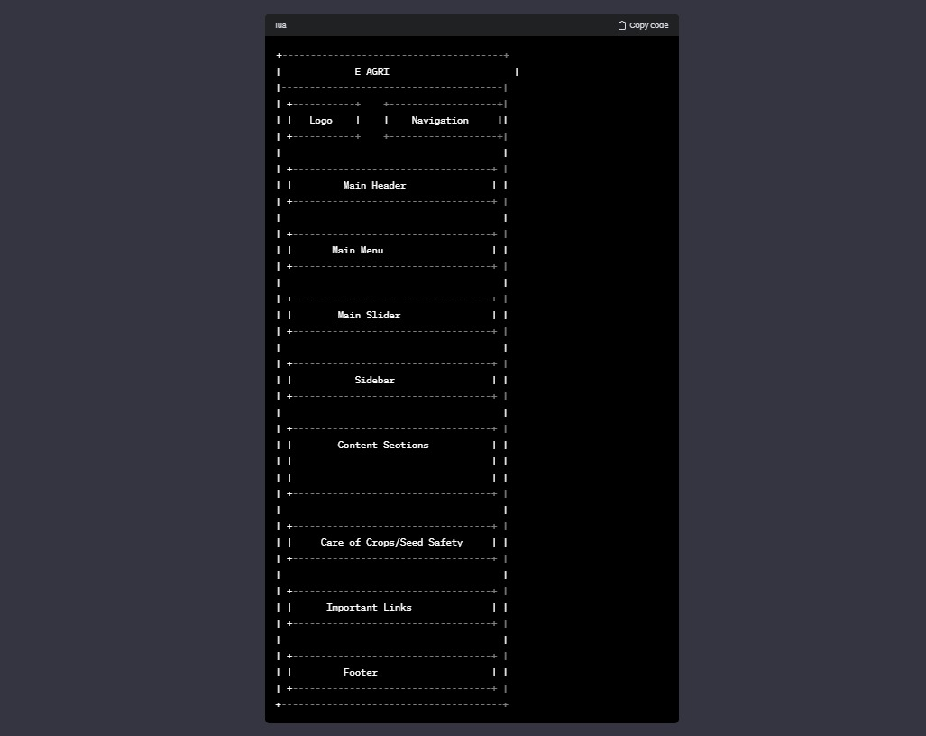

**5. SYSTEM REQUIREMENTS**

**5.1. Technologies Used:**

· HTML

· CSS

· Java Script

· Bootstrap

· jQuery

**HTML:**

HTML, an initialism of Hypertext Markup Language, is the predominant markup language for web pages. It provides a means to describe the structure of text-based information in a document.HTML (Hyper Text Markup Language) is the code that is used to structure a web page and its content. For example, content could be structured within a set of paragraphs, a list of bulleted points, or using images and data tables.

**CSS:**

CSS (cascading style sheets) works in conjunction with HTML and is directly responsible for dictating color, background, text color, font, positioning and additional features to the web browser. CSS is a key component of web development.

CSS (Cascading Style Sheets) is used to style and layout web pages — for example, to alter the font, color, size, and spacing of your content, split it into multiple columns, or add animations and other decorative features. However, the web would be a boring place if all websites looked like that. Using CSS, you can control exactly how HTML elements look in the browser, presenting your markup using whatever design you like. a user agent, which basically means a computer program that represents a person inside a computer system. Browsers are the main type of user agents we think of when talking about CSS, however, they are not the only ones. There are other user agents available, such as those that convert HTML and CSS documents into PDFs to be printed.

**Boot Strap:**

Bootstrap is a free, open-source front-end development framework for the creation of websites and web apps. Designed to enable responsive development of mobile-first websites, Bootstrap provides a collection of syntax for template designs. Bootstrap is a free front-end framework, with the purpose of making web development faster and easier. It also includes HTML and CSS-based design templates for forms, typography, buttons, navigation, tables, modals, image carousels, and many other components along with other optional JavaScript plugins. As a framework, Bootstrap includes the basics for responsive web development, so developers only need to insert the code into a pre-defined grid system. The Bootstrap framework is built on Hypertext Markup Language (HTML), cascading style sheets (CSS) and JavaScript. Web developers using Bootstrap can build websites much faster without spending time worrying about basic commands and functions.

**Java script:**

JavaScript is a script-based programming language that was developed by Netscape Communication Corporation. JavaScript was originally called Live Script and renamed as JavaScript to indicate its relationship with Java. JavaScript (JS) is a cross-platform, object-oriented programming language used by developers to make web pages interactive. It allows developers to create dynamically updating content, use animations, pop-up menus, clickable buttons, control multimedia, etc. JavaScript helps users create modern web applications for direct interaction without reloading the page each time. It not only works in browsers but has many other uses.

**JQuery:**

jQuery is a fast, small, and feature-rich JavaScript library. It makes things like HTML document traversal and manipulation, event handling, animation, and Ajax much simpler with an easy-to-use API that works across a multitude of browsers. jQuery is a lightweight, "write less, do more", JavaScript library. The purpose of jQuery is to make it much easier to use JavaScript on your website. jQuery takes a lot of common tasks that require many lines of JavaScript code to accomplish, and wraps them into methods that you can call with a single line of code.

**6. SYSTEM DESIGN**

**6.1. Behavioral Diagrams:**

**6.1.1. Use Case Diagram:**

Use case Diagrams represent the functionality of the system from a user’s point of view. Use cases are used during requirements elicitation and analysis to represent the functionality of the system. Use cases focus on the behavior of the system from an external point of view. Actors are external entities that interact with the system. Examples of actors include users like administrator, farmers, agriculture students etc., or another system like central database. In UML, use-case diagrams model the behavior of a system and help to capture the requirements of the system. Use-case diagrams describe the high-level functions and scope of a system. These diagrams also identify the interactions between the system and its actors. Use-case diagrams illustrate and define the context and requirements of either an entire system or the important parts of the system. You can model a complex system with a single use-case diagram or create many use-case diagrams to model the components of the system. You would typically develop use-case diagrams in the early phases of a project and refer to them throughout the development process. Before starting a project, you can create use-case diagrams to model a business so that all participants in the project share an understanding of the workers, customers, and activities of the business.

**Description:**

**Name of the Use Case:** login

**Description:** Every user should login to access the services provided by the farmers buddy system.

**Pre Condition:** Each user must have a valid user id and password**.**

**Post Condition:** Home Page will be displayed.

**Flow of events:** · Enter the home page.

**Name of the Use Case:** soil

**Description:**

In this, we add information about various soils that are available and also we can update, delete the information about soils. User after registered with this system can view this information provided.

**Pre Condition:** Each user must have a valid user id and password**.**

**Post Condition:** Required Page will be displayed.

**Flow of events:** · We can add soils into the system.

· We can update and delete soil information

**Name of the Use Case:** crop

**Description:**

In this, we add information about various crops that are available and also we can update, delete the information about crops to be grown in various soils according to climatic conditions. User after registered with this system can view this information provided.

**Pre Condition:** Each user must have a valid user id and password**.**

**Post Condition:** Required Page will be displayed.

**Flow of events:**

* We can add crop information into the system
* We can update and delete crop information

**Name of the Use Case:** fertilizer:

**Description:**

In this, we add information about various fertilizers that are available and also we can update, delete the information about fertilizers to be used in various soils according to climatic conditions. Users after registering with this system can view this information provided.

**Pre-Condition:** Each user must have a valid user id and password**.**

**Post Condition:** Required Page will be displayed.

**Flow of events:**

* We can add fertilizer information into the system
* We can update and delete fertilizer information

**Name of the Use Case:** commodity

**Description:**

In this, we add, update and delete the information about various commodities that are available in markets corresponding to particular areas in particular state and district. User after registered with this system can view this information provided.

**Pre Condition:** Each user must have a valid user id and password**.**

**Post Condition:** Required Page will be displayed.

**Flow of events:**

* We can add commodity information into the system
* We can update and delete commodity information

**Name of the Use Case:** market

**Description:**

In this, we add, update and delete information about various markets. User after registered with this system can view this information provided.

**Pre Condition:** Each user must have a valid user id and password**.**

**Post Condition:** Required Page will be displayed.

**6.2 System Specific Modules :**

It has been modularized into following modules:

1. Home Page

2. Soils and Fertilizers

3. Crop Management

4. E Agricultre

5. Schemes

6. Machinery

7. Mobile Apps

8. Weather

9. Contact

**1.** **Home Page:**

First, to enter this system the users has to enter to this system. Basically there are 3 types of users in this system.

* Admin users - Has full access to all the modules of this system.
* Farmers and Agriculture Students – Has restricted access. i.e., Normal users have access to some of the modules only.
* Agricultural officers: Has also restricted access.

**2.** **Soils and Fertilizers:**

This module is used to maintain the various Soils and Fertilizers Details. This module will be enabled only to the admin type of users.

This module contains:

· A separate screen should be provided to maintain the Soils and Fertilizers Details. It should provide a way to add, modify and delete the both details.

· If a new Soil Information is received it should be added to the System.

· If a new Fertilizer information is received it should be added to the system with the corresponding details like soil name, crop type, crop name etc.

**3.Crop Details:**

This module is used to maintain the various details about crops. This module will be enabled only to the admin type of users.

This module contains:

· A separate screen should be provided to maintain the Crops Information. It should provide a way to add, modify and delete the crop details.

· If a new crop information is received, it should be added to the system with the corresponding details like Soil Name, Crop Type, Crop Name and Season.

**4.Market Details:**

In this module we can maintain the market details. This module will be enabled only to the admin type of users.

This module contains:

· A separate screen should be provided to maintain the market related information. It should provide a way to add, modify and delete the market related information.

· Administrator type of user can add the commodities in the market.

· He can add the information about new markets into the system.

· He can add the market report into the system regarding a particular market and commodities prices details in that market in a day.

**5.Schemes**

This module is used to prepare various Schemes.

(i) Soil Health Card Scheme:

The Soil Health Cards provide information to farmers on nutrient status of their soil along with recommendation on appropriate dosage of nutrients to be applied for improving soil health and its fertility.

(II) Neem Coated Urea (NCU):

Scheme being promoted to regulate use of urea, enhance availability of nitrogen to the crop and reduce cost of fertilizer application. NCU slows down the release of fertilizer and makes it available to the crop in an effective manner.

**6.4 Screen**

**Step1: First page:**

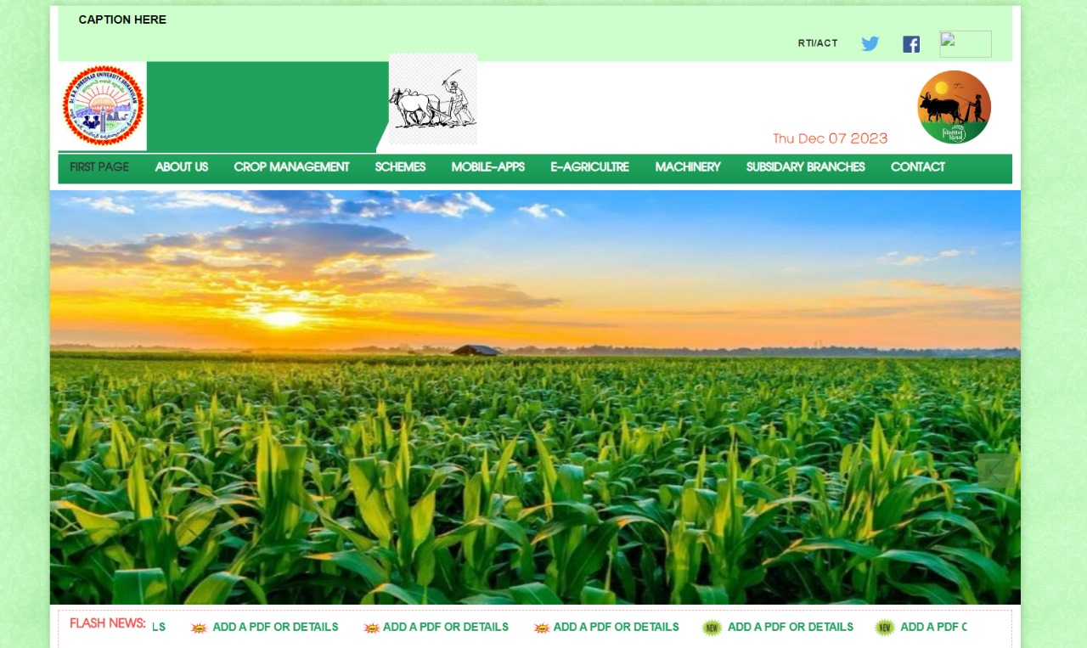

**Step 2: About us:**

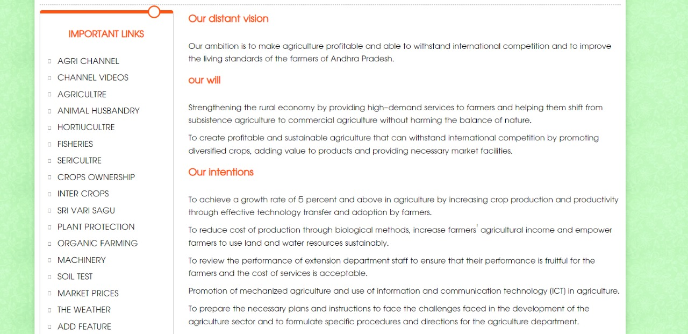

**Step 3: Crop Management:**

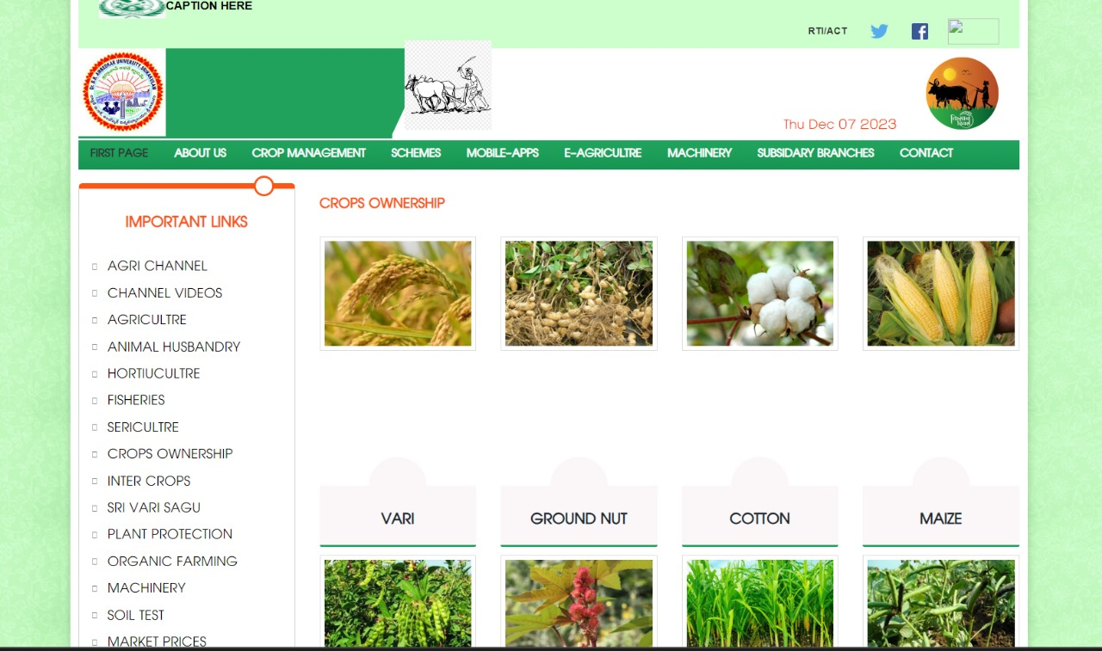

**Step 4: Machinery :**

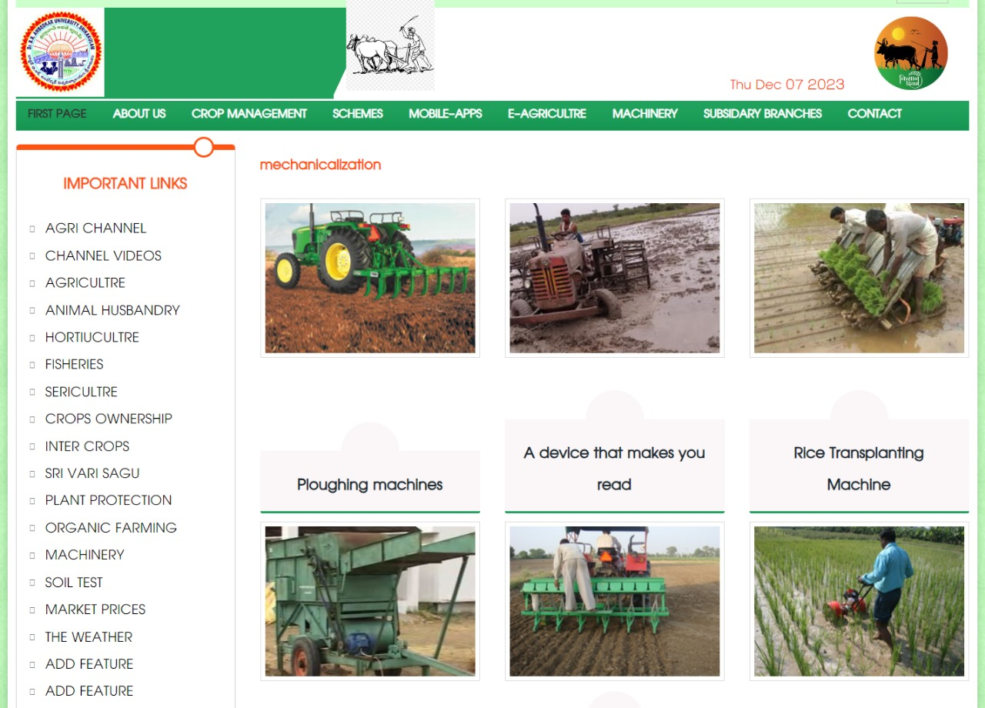

**Step 5: Mobile apps:**

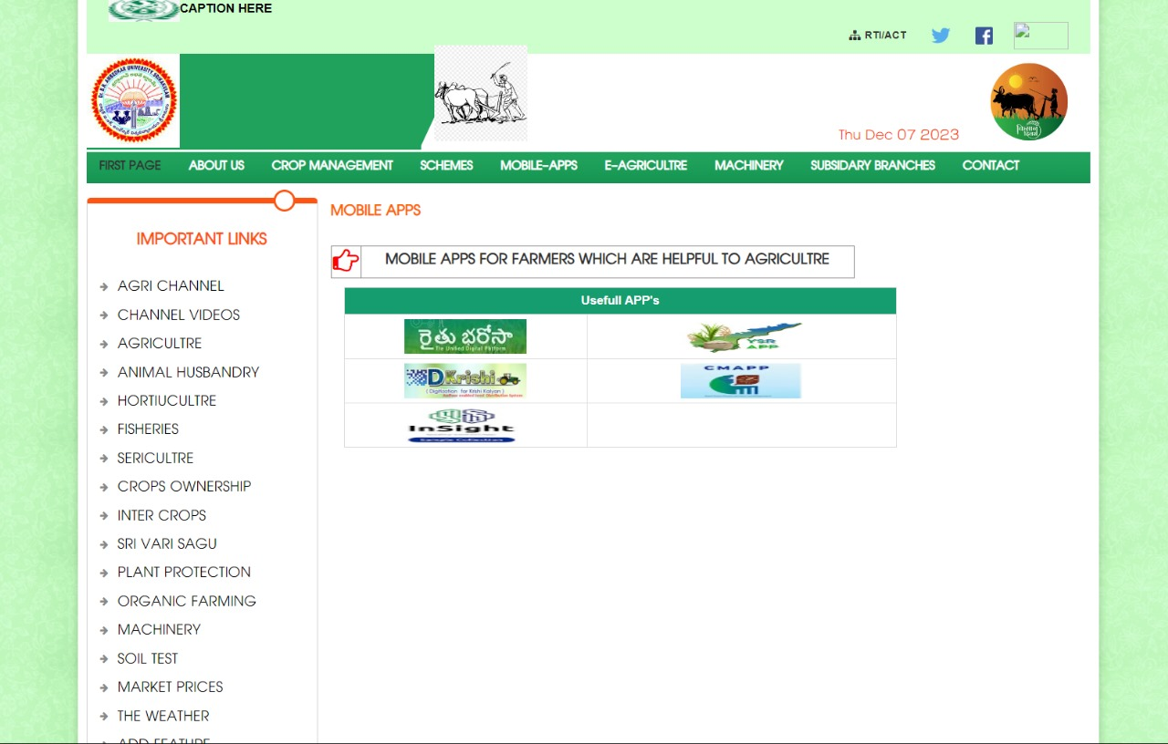

**Step 6: Fertilizer Information:**

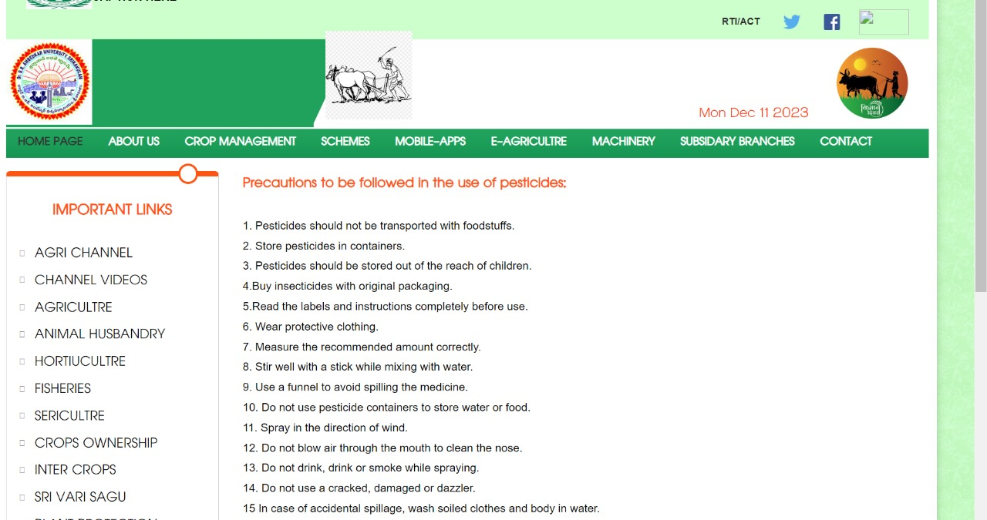

**Step 7: weather:**

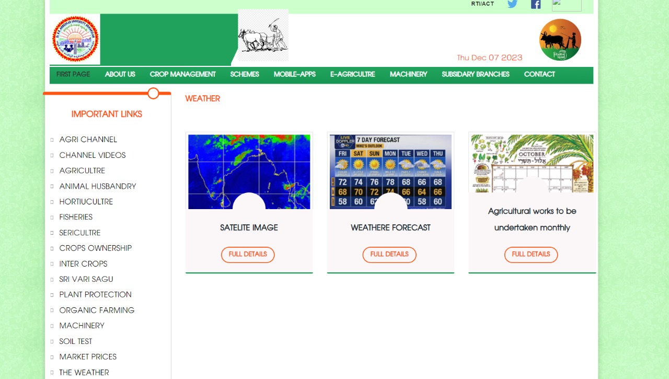

**Step 8: contact us:**

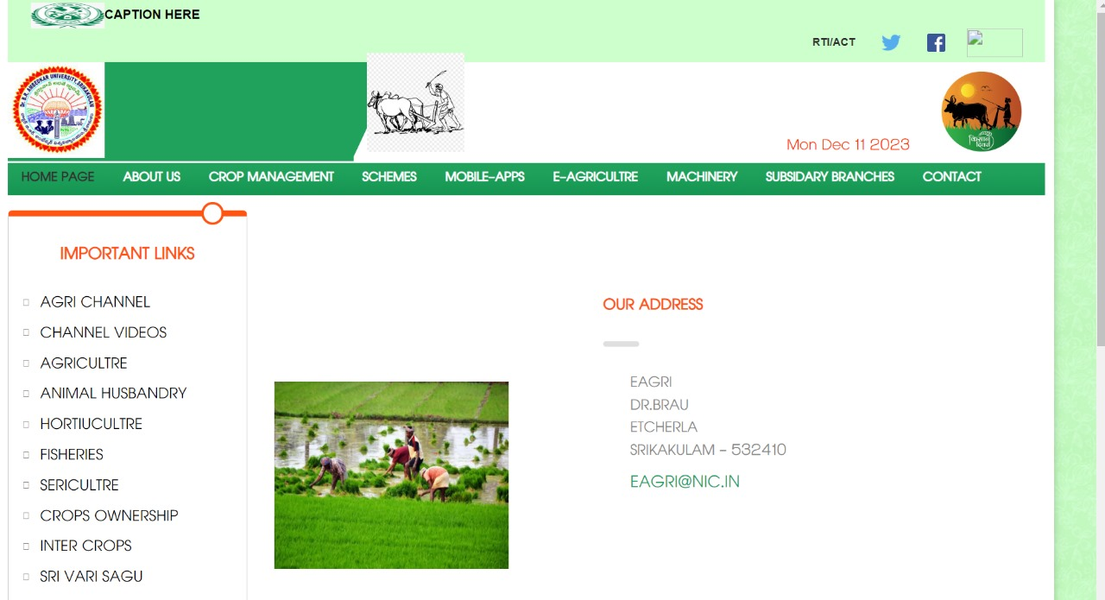

**6.5 Source code**

**Index.html:**

<!DOCTYPE html>

<html>

<head>

<meta charset="utf-8">

<title>.:: E AGRI::.</title>

<link rel="icon" href="images/favicon.png">

<style type="text/css">

<!-- .style1 {

color: #1D222D

}

-->

</style>

</head>

<body>

<div class="page-wrapper">

<p>&nbsp;</p>

<div class="preloader"></div>

<div class="container" style="background:#fff; padding:0 10px;-webkit-box-shadow: 0 0 10px 0 rgba(0, 0, 0, 0.2);box-shadow: 0 0 10px 0 rgba(0, 0, 0, 0.2);">

<link href="css/bootstrap.min.css" rel="stylesheet">

<link rel="shortcut icon" href="images/favicon.png">

<link href="css/revolution-slider.css" rel="stylesheet">

<link href="css/t-style.css" rel="stylesheet">

<link href="css/fonts.css" rel="stylesheet">

<meta http-equiv="X-UA-Compatible" content="IE=edge">

<meta name="viewport" content="width=device-width, initial-scale=0.8, maximum-scale=0.8, user-scalable=1">

<link href="css/responsive.css" rel="stylesheet" type="text/css">

<style>

.main-menu .navigation>li>a {

font-size: 18px;

}

.main-menu .navigation>li {

margin-right: 32px;

}

.dtcls {

font-size: 15px;

color: #F30;

font-weight: 600;

right: 13%;

top: 85%;

position: absolute;

font-family: 'PT Sans', sans-serif;

}

.style3 {

color: #00FF00

}

</style>

<header class="main-header" id="main-header">

<div class="header-top">

<div class="auto-container clearfix">

<div class="col-md-8">

<div class="top-left">

<ul class="clearfix ">

<li><strong>CAPTION HERE</strong></li>

</ul>

</div>

</div>

<div class="col-md-12">

<div class="top-right">

<ul class="clearfix">

<li><a href="rtiact.html"><span class="fa fa-sitemap"></span><b>RTI/ACT</b></a></li>

<li><a href="https://twitter.com/ap_agriculture" target="_blank"><img src="images/tw.png" width="32" height="32"/></a></li>

<li><a href="https://www.facebook.com/APAgricultureDept" target="_blank"><img src="images/fb.png" width="20" height="20"/></a></li>

<li><a href="https://spandana.ap.gov.in/" target="_blank"><img src="images/jkc.PNG" width="62" height="32"/></a></li>

</ul>

</div>

</div>

</div>

</div>

<div class="header-lower">

<div class="auto-container clearfix">

<div class="outer-box">

<div class="col-md-4" style="padding:0;">

<div class="logo">

<a href="#">

<img src="images/agri.logo.jpg" alt="agriculture ap" />

</a>

</div>

</div>

<div class="col-md-5">

<div style="margin:-10px 0 0 0px;"><img src="images/agri-logo1.jpg" alt="agri logo" height="110" /></div>

</div>

<div class="col-md-3">

<div style="float:right">

<img src="images/EAGRI.jpg" alt="farmer logo" width="110" /> </div>

</div>

</div>

</div>

</div>

<div class="dtcls">

<p id="demo"></p>

<script>

var d = new Date();

document.getElementById("demo").innerHTML = d.toDateString();

</script>

</div>

</header>

<nav class="main-menu" style="margin-bottom:7px;">

<div class="navbar-header">

<button type="button" class="navbar-toggle" data-toggle="collapse" data-target=".navbar-collapse">

<span class="icon-bar"></span>

<span class="icon-bar"></span>

<span class="icon-bar"></span>

</button>

</div>

<div class="navbar-collapse collapse clearfix">

<ul class="navigation">

<li class="dropdown current"><a href="index.html">HOME PAGE</a></li>

<li><a href="ABOUT.html">ABOUT US</a></li>

<li><a href="crops.html"> CROP MANAGEMENT</a></li>

<li><a href="schemes.html">SCHEMES</a></li>

<li><a href="mobile.html">MOBILE-APPS</a></li>

<li><a href="https://eseed.ap.gov.in/eseed/" target="_blank">E-AGRICULTRE</a></li>

<li><a href="YSR yantra.html" target="_blank">MACHINERY</a></li>

<li><a href="sub.html">SUBSIDARY BRANCHES</a></li>

<li><a href="contactus.html">CONTACT</a></li>

</ul>

</div>

</nav>

<section class="main-slider">

<style>

.department .department-details h4 {

color: #202A30;

font-weight: 600;

font-size: 24px;

}

.department {

border-bottom: 3px solid #20a25d;

border-radius: 0 0 2px 2px;

margin-bottom: 10px;

min-height: 380px;

overflow: hidden;

position: relative;

}

.thead {

color: #ff5412;

font-weight: 700;

font-size: 26px;

margin-bottom: 20px;

}

.targetDiv {

display: none

}

</style>

<div class="row">

<div class="col-md-11.0" style="padding-right:0;" align="center">

<div class="slider_container">

<div class="flexslider">

<ul class="slides">

<li>

<a href="#"><img src="images/pro2.jpg" alt="agriculture ap" title=""/></a>

</li>

<li>

<a href="#"><img src="images/pro1.jpg" alt="agriculture ap" title=""/></a>

</li>

<li>

<a href="#"><img src="images/pro5.jpg" alt="agriculture ap" title=""/></a>

</li>

<li>

<a href="#"><img src="images/pro6.jpg" alt="agriculture ap" title=""/></a>

</li>

<li>

<a href="#"><img src="images/pro7.jpg" alt="agriculture ap" title=""/></a>

</li>

<li>

<a href="#"><img src="images/pro8.jpg" alt="agriculture ap" title=""/></a>

</li>

</ul>

</div>

</div>

</div>

</div>

<div class="row">

<div class="col-md-12" style="padding-top:7px;">

<div class="alert-box alert-danger" style="padding:4px; margin-bottom:10px; overflow:hidden; background:#fff; border:1px dashed #f39f9f">

<div class="inner">

<span class="fa fa-newspaper-o"></span> FLASH NEWS: &nbsp;

</div>

<div class="latestnews" style="color:#333; float:left; font-weight:bold; width:86%;">

<marquee scrollamount="6" onMouseOver="this.stop()" onMouseOut="this.start()">

<ul class="clearfix">

<li><img src="images/new2.gif" width="28" height="24" alt="gif"><a href="pdf/.PDF" target="_benderlank">ADD A PDF OR DETAILS</li>

<li><img src="images/new2.gif" width="28" height="24" alt="gif"><a href="pdf/.PDF" target="_benderlank">ADD A PDF OR DETAILS</li>

<li><img src="images/new2.gif" width="28" height="24" alt="gif"><a href="pdf/.pdf" target="_benderlank"> ADD A PDF OR DETAILS</li>

<li><img src="images/new2.gif" width="28" height="24" alt="gif"><a href="pdf/.pdf" target="_benderlank"> ADD A PDF OR DETAILS </li>

<li><img src="images/new2.gif" width="28" height="24" alt="gif"><a href="pdf/.pdf" target="_benderlank"> ADD A PDF OR DETAILS</li>

<li><img src="images/new2.gif" width="28" height="24" alt="gif"><a href="pdf/.pdf" target="_benderlank">ADD A PDF OR DETAILS</li>

<li><img src="images/new2.gif" width="28" height="24" alt="gif"><a href="pdf/.pdf" target="_benderlank">ADD A PDF OR DETAILS</li>

<li><img src="images/new1.gif" width="28" height="24" alt="gif"><a href="pdf/.pdf" target="_blank"><span class="fa fa-circle"></span>ADD A PDF OR DETAILS </a></li>

<li><img src="images/new1.gif" width="28" height="24" alt="gif"><a href="pdf/.pdf" target="_blank"><span class="fa fa-circle"></span>ADD A PDF OR DETAILS </a></li>

<li><img src="images/new1.gif" width="28" height="24" alt="gif"><a href="pdf/.pdf" target="_blank"><span class="fa fa-circle"></span> ADD A PDF OR DETAILS</a></li>

</ul>

</marquee>

</div>

</div>

</div>

</div>

<div class="row">

<div class="col-md-12">

<div id="slide03" style="border: 1px dashed #ccc; overflow: hidden;">

<div style="margin-left:2px;">

</section>

<section>

<style>

a{

cursor:pointer

}

</style>

<div class="row">

<div class="col-md-3 col-sm-4 col-xs-12 pull-left">

<aside class="sidebar" style="margin:10px 0 10px 0;">

<article class="column progress-column clr-orange">

<div class="inner-box">

<div class="top-icon"></div>

<div class="widget links-widget" style="margin-bottom:0;">

<h3>Important links </h3>

<ul>

<li><a href="https://www.youtube.com/channel/UCO1WYLWX1u7-ADiWfvvo2_Q" target="_blank">AGRI CHANNEL</a></li>

<li><a href="agriv.html">CHANNEL VIDEOS</a></li>

<li><a href="Agrivideos.html">AGRICULTRE</a></li>

<li><a href="Animalvideos.html">ANIMAL HUSBANDRY</a></li>

<li><a href="Hortivideos.html">HORTIUCULTRE</a></li>

<li><a href="Fishvideos.html">FISHERIES</a></li>

<li><a href="Serivideos.html">SERICULTRE</a></li>

<li><a href="crops.html">CROPS OWNERSHIP</a></li>

<li><a href="intercrops.html">INTER CROPS</a></li>

<li><a href="srivarisagu.html">SRI VARI SAGU</a></li>

<li><a href="plant protection.html">PLANT PROTECTION</a></li>

<li><a href="organic farming.html">ORGANIC FARMING</a></li>

<li><a href="machinery.html">MACHINERY</a></li>

<li><a href="http://soilhealth.dac.gov.in/" target="_blank">SOIL TEST</a></li>

<li><a href="http://market.ap.nic.in/" target="_blank">MARKET PRICES</a></li>

<li><a href="weather.html">THE WEATHER</a></li>

</ul>

</div>

</div>

</article>

</aside>

</div>

<div>

</div>

<div class="auto-container">

<div class="row clearfix">

<div class="col-md-4 col-sm-6 col-xs-12 column">

<article class="inner-box">

<div class="content">

<h3>Ownership of crops</h3>

<div class="text">

<p>Soil preparation ,sowing time,seed treatment,Planting depth,Fertilizetr application,Weed Control ... <br />

<a class="thm-btn a-inner letter-spacing-1" href="crops.html">Full Details.</a>

</p>

</div>

</div>

</article>

</div>

<div class="col-md-4 col-sm-6 col-xs-12 column">

<article class="inner-box">

<div class="content">

<h3>Inter crops</h3>

<div class="text">

<p> crops grown between rows of main crop are called inter crops.. These helps in high beneficiary in crops <br />

<a class="thm-btn a-inner letter-spacing-1" href="intercrops.html">Full details.</a>

</p>

</div>

</div>

</article>

</div>

<div class="col-md-4 col-sm-6 col-xs-12 column">

<article class="inner-box">

<div class="content">

<h3>SRIVARISAGU</h3>

<div class="text">

<p>. 8 TO 12 days old two-leaved fibre should be planted only.This causes a large no of calls of leaves and make strong .. &nbsp; <br>

<a class="thm-btn a-inner letter-spacing-1" href="srivarisagu.html">Details.</a>

</p>

</div>

</div>

</article>

</div>

<div class="col-md-4 col-sm-6 col-xs-12 column">

<article class="inner-box">

<div class="content">

<h3>COMPREHENSIVE PLANT PROTECTION</h3>

<div class="text">

<p>Comprehensive plant protection means regular assesment various pests on trees without damaging the ecological balance...<br />

<a class="thm-btn a-inner letter-spacing-1" href="plant protection.html">details.</a>

</p>

</div>

</div>

</article>

</div>

<div class="col-md-4 col-sm-6 col-xs-12 column">..

<article class="inner-box">

<div class="content">

<h3>Organic Farming</h3>

<div class="text">

<p>Organic farming can be described as organic that is envoironmetal friendly and prepared by nature organic farming.. <br />

<a class="thm-btn a-inner letter-spacing-1" href="organic _farming.html">Details. </a>

</p>

</div>

</div>

</article>

</div>

<div class="col-md-4 col-sm-6 col-xs-12 column">

<article class="inner-box">

<div class="content">

<h3>Mechanization</h3>

<div class="text">

<p>From subsistence farming by providing services that are in high demand to farmers without harming the balance of nature</p>. <br />

<a class="thm-btn a-inner letter-spacing-1" href="machinery.html">details. </a>

</p>

</div>

</div>

</article>

</div>

</div>

</div>

</section>

<section class="sec-paddingt6 bg-f1">

<div class="auto-container clear-space">

<div class="sec-title">

<h2> Care of Crops/Seed Safety</h2>

<div class="line"></div>

</div>

<div class="sec-content m-top50">

<div class="row">

<div class="col-xs-12 col-sm-6 col-md-3 col-lg-3">

<div class="department">

<div class="thumb">

<img class="img-responsive img-fullwidth" src="images/resource/featured-image-4.jpg" alt="agriculture ap">

</div>

<div class="department-details">

<div class="round-style"></div>

<h4 class="title">Safeguards in the use of pesticides</h4>

<p class="details sec-padding5">Organic farming prices, farmers Success stories, contact details,media,channel braoadcastins,effilate branches dealer list .</p>

<a href="pesticide.html" class="thm-btn btn-xs img-inner"><i class="fa fa-angle-double-right"></i>details</a>

</div>

</div>

</div>

<div class="col-xs-12 col-sm-6 col-md-3 col-lg-3">

<div class="department">

<div class="thumb">

<img class="img-responsive img-fullwidth" src="images/resource/featured-image-10.jpg" alt="agriculture ap">

</div>

<div class="department-details">

<div class="round-style"></div>

<h4 class="title">precautions in seed cleaning</h4>

<p class="details sec-padding5">Organic farming prices, farmers Success stories, contact details,media,channel braoadcastins,effilate branches dealer list </p>

<a href="#" class="thm-btn btn-xs img-inner"><i class="fa fa-angle-double-right"></i>Watch Video</a>

</div>

</div>

</div>

<div class="col-xs-12 col-sm-6 col-md-3 col-lg-3">

<div class="department">

<div class="thumb">

<img class="img-responsive img-fullwidth" src="images/resource/featured-image-6.jpg" alt="agriculture ap">

</div>

<div class="department-details">

<div class="round-style"></div>

<h4 class="title">Precautions in the use of insectcides </h4>

<p class="details sec-padding5">Organic farming prices,farmers Success stories ,contact details,media,channel braoadcastins,effilate branches dealer list </p>

<a href="insecticide.html" class="thm-btn btn-xs img-inner"><i class="fa fa-angle-double-right"></i>details</a>

</div>

</div>

</div>

<div class="col-xs-12 col-sm-6 col-md-3 col-lg-3">

<div class="department">

<div class="thumb">

<img class="img-responsive img-fullwidth" src="images/resource/featured-image-7.jpg" alt="agriculture ap">

</div>

<div class="department-details">

<div class="round-style"></div>

<h4 class="title">PRECAUTIONS IN PREPARATION OF MIXTURE</h4>

<p class="details sec-padding5">Organic farming prices, farmers Success stories, contact details,media,channel braoadcastins,effilate branches dealer list .</p>

<a href="mixture.html" class="thm-btn btn-xs img-inner"><i class="fa fa-angle-double-right"></i>DETAILS</a>

</div>

</div>

</div>

</div>

</div>

</div>

</section>

<footer class="main footer">

<div class="footer-upper">

<div class="go-up">

<div class="curve scroll-to-target" data-target="#main-header"><span class="icon fa fa-arrow-up"></span></div>

</div>

<div class="container">

<div class="row">

<div class="col-md-4 col-sm-4 col-xs-12 column">

<div class="footer-widget about-widget">

<h2>ABOUT E AGRICULTRE</h2>

<div class="text">

<p style="font-size:17px;">EAGRI <br /> DR. BRAU<br /> ETCHERLA<br/> SRIKAKULAM - 532410. </p>

</div>

</div>

</div>

</div>

</div>

</div>

<div class="footer-bottom">

<div class="auto-container">

<div class="row">

<div class="col-md-6">

<div class="copyright">©2023 E-AGRI WEBSITE </div>

</div>

<div class="col-md-12">

<p style="font-size:17px;"> WEBSITE DESIGNED BY <a href="http://127.0.0.1:5501/index.html" class="thead" style="font-size:18px;" target="_blank">Agriculture Department</a> </p>

</div>

</div>

</div>

</div>

</footer>

</div>

</div>

</body>

</html>

**6.6 System Evolution**

Our system should provide services to the users who are existing in this system. The administrator, agricultural students, general public, agricultural officer can use the benefits of the system who are having valid internet knowledge

**System to be changed:**

In the existing system periodic generation of reports takes lot of time. It is time consuming and lot of complications will arise. So there is necessity to change the system and then the time taking will be very short.

**System understanding:**

Complete understanding of the system that is to be done i.e. brief study of the requirements and designing of the system is to be developed.

**System validation:**

Validation can be found in many ways, but a simple definition is that validation succeeds when software functions in a manner that can be reasonably expected by the user, i.e. fulfilling all the user specified requirements.

**7.RESULT**

**E-AGRI WEBSITE HOMWPAGE**

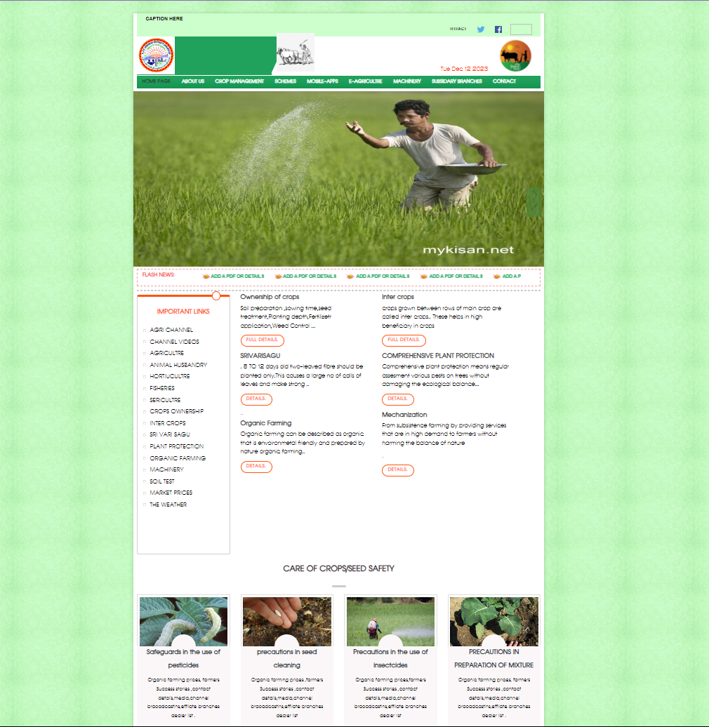

**8.CONCLUSION**

By this project, we provide various information required for farmers and agricultural students and also providing solutions to them about queries posted by them. This makes agriculture more ecofriendly and this portal is very useful to farmers and agricultural students.

In conclusion, Agriculture has given so much to society. But it has its own pros and cons that we can’t overlook. Furthermore, the government is doing every bit to help in the growth and development of agriculture; still, it needs to do something for the negative impacts of agriculture. To save the environment and the people involved in it.

FAQs about Essay on Agriculture

Q.1 Name the four types of agriculture?

A.1 The four types of agriculture are nomadic herding, shifting cultivation, commercial plantation, and intensive subsistence farming.

Q.2 What are the components of the agricultural revolution?

A.2 The agricultural revolution has five components namely, machinery, land under cultivation, fertilizers, pesticides, irrigation, and a high-yielding variety of seeds

**9. APPENDIX A**

**- Hardware and Software Configurations**

**HARDWARE REQUIREMENTS:**

Processor : windows xp

Hard Disk : 4GB

RAM : 512MB or more

**SOFTWARE REQUIREMENTS:**

Operating System : Windows XP/2003 or Linux

User Interface : HTML, CSS

Client-side Scripting : JavaScript

Programming Language : Java

Database : workbench

Deployment : Tomcat 5.0,live server

**10. Appendix B**

**- Limitations and Enhancements**

**Limitations:**

* It is open discussion forum so that everyone uploads unwanted and wrong information so that it misleads the students and farmers.
* Quite inefficiency in querying details.

**Enhancements:**

It is not possible to develop a system that makes all the requirements of the user. User requirements keep changing as the system is being used. Some of the future enhancements that can be done to this system are:

* As the technology emerges, it is possible to upgrade the system and can be adaptable to desired environment.
* Because it is based on object-oriented design, any further changes can be easily adaptable.
* Based on the future security issues, security can be improved using emerging technologies.
* Case Registration module can be added

**11.** **REFERENCE:**

**References:**

(1) Chat gpt.

(2) Google

(3) ekarshak.ap.gov.in

(4) https://farmer.gov.in

(5) https://www.apagrisnet.gov.in

(6) e-crop